IRSTI 34.31.35
Research article

Molecular identification and diversity of Aspergillus storage fungi in chickpea seeds from the Akmola region, Kazakhstan

R.S. Uakhit¹, A.M. Smaggulova², A.S. Abash³,
V.S. Kiyan⁴, K.A. Dyussembayev*⁵

^{1,2,4,5}Laboratory of Biodiversity and Genetic Resources, National Center of Biotechnology, Astana, Kazakhstan
³Higher School of Natural Sciences, Astana International University, Astana, Kazakhstan
⁵Department of Biotechnology and Microbiology, L.N. Gumilyov Eurasian National University, Astana, Kazakhstan

E-mail: erken.uakhitrabiga@gmail.com¹, smagulova0114@gmail.com², altın_jan82@mail.ru³, vskiyan@gmail.com⁴, dyussembayev@biocenter.kz⁵

Abstract. Chickpea (Cicer arietinum L.) is a vital legume whose post-harvest quality is frequently compromised by opportunistic storage fungi, posing both economic losses and potential health risks due to mycotoxin contamination. Despite its agricultural importance, information regarding storage fungi affecting chickpea seeds in Kazakhstan remains limited. This study aimed to isolate and identify Aspergillus species contaminating chickpea seeds cultivated in the Akmola region. Over 200 seed samples representing local agricultural production were evaluated. Initial microbiological analysis and microscopic examination were followed by accurate molecular identification through the amplification sequencing of the internal transcribed spacer (ITS) region of ribosomal DNA. Phylogenetic analysis of the obtained sequences confirmed the presence of two distinct species: Aspergillus niger and Aspergillus fumigatus. The isolation of these ubiquitous saprophytes indicates significant post-harvest fungal proliferation, likely exacerbated by local climatic factors and storage microclimates. These findings highlight a critical vulnerability in regional post-harvest infrastructure and underscore the necessity for rigorous phytosanitary monitoring. Implementing improved, sustainable storage management strategies is essential to mitigate fungal contamination and ensure the safety of local agricultural commodities.
Keywords: Cicer arietinum, storage fungi, Aspergillus niger, Aspergillus fumigatus, ITS rDNA, phytosanitary monitoring, post-harvest quality

DOI: https://doi.org/10.32523/2789-4320-2024-1-x-x

Received: XX.XX.XXXX. Accepted: XX.XX.XXXX. Available online: XX.XX.XXXX.

*Corresponding author

Introduction

Chickpea (Cicer arietinum L.) is one of the most important grain legumes cultivated worldwide and represents a major source of plant protein for human nutrition [1]. The crop is widely grown in semi-arid and temperate regions of Asia, the Middle East, and Africa, and is increasingly grown in Europe and Central Asia [2]. By fixing atmospheric nitrogen and offering high nutritional value, chickpea is integral to sustainable agricultural systems and soil fertility management. [3]. However, the productivity of chickpea is strongly constrained by numerous fungal diseases affecting plants at different developmental stages [4-6].
Aspergillus spp. are ubiquitous filamentous fungi widely distributed in soil, air, and plant debris [5-7]. Numerous Aspergillus species opportunistically colonize agricultural commodities, particularly when elevated temperature and humidity during storage promote fungal proliferation. In chickpea seeds, Aspergillus species can develop under inadequate storage conditions, such as high moisture content, poor ventilation, or prolonged storage periods [8]. These fungi can rapidly colonize seed surfaces and internal tissues, leading to deterioration of seed quality, reduced germination capacity, and potential loss of market value [9].
In addition to causing economic losses, contamination of food products by Aspergillus spp. represents a potential risk to human health [10-14]. Some species in this genus produce mycotoxins, including aflatoxins and ochratoxins, which can accumulate in contaminated food products. Furthermore, Aspergillus spores and fungal metabolites may trigger allergic reactions in susceptible individuals. Exposure to fungal spores through inhalation or consumption of contaminated food may lead to hypersensitivity reactions, respiratory symptoms, or other allergic manifestations. These effects are associated with the presence of allergenic proteins and secondary metabolites produced by certain Aspergillus species [15].
Because chickpea seeds are widely consumed and often stored for extended periods before processing or consumption, monitoring for fungal contamination is essential to ensure food safety and quality [16]. The identification of Aspergillus species associated with stored chickpea seeds is therefore important for understanding the sources of contamination and assessing potential risks for consumers [17]. Traditional morphological identification of fungi may be limited by similarities among species; therefore, molecular methods, such as PCR amplification and sequencing of ribosomal DNA regions, provide a reliable approach to accurate species identification [18].
Despite the importance of chickpea production in many regions, information regarding the occurrence and molecular identification of storage fungi associated with chickpea seeds remains limited in several countries, including Kazakhstan. Therefore, studying the diversity of Aspergillus species contaminating chickpea seeds is necessary to improve phytosanitary monitoring and to support the development of effective storage management strategies aimed at reducing fungal contamination and associated health risks [19, 20].

Materials and methods

Sample collection
Chickpea (Cicer arietinum L.) seed samples were collected from agricultural fields located in the Akmola region of Kazakhstan. The samples were provided by the A.I. Baraev Scientific Production Center for Grain Farming (Shortandy, Kazakhstan). In total, more than 200 chickpea seed samples were examined during the study period. Seeds were collected from different batches representing local agricultural production. All samples were placed in sterile containers, labeled, and transported to the laboratory for further mycological analysis.
Prior to microbiological analysis, seeds underwent visual inspection to detect overt fungal contamination and morphological anomalies. Individual seeds from each sample were selected randomly for further microscopic and molecular investigations.

Microbiological analysis and microscopic examination
Chickpea seeds were subjected to microbiological analysis to isolate fungal contaminants. Individual seeds were placed on Petri dishes containing potato dextrose agar (PDA) medium and incubated at 25 ± 2 °C for 5–7 days. Emerging fungal colonies were monitored daily, and colonies with morphological characteristics were selected for further examination.
For microscopic analysis, small fragments of fungal colonies were transferred onto microscope slides in a drop of sterile distilled water and covered with a coverslip. Microscopic observations were performed using a Zeiss Axio Scope light microscope (Carl Zeiss, Germany).

DNA extraction and PCR amplification
Genomic DNA was extracted from the fungal mycelium of Aspergillus spp. grown on potato dextrose agar (PDA). A small fragment of fungal mycelium (approximately 0.5 × 0.5 cm) was transferred from the culture plate into a sterile mortar. Then, 300 μL of extraction buffer containing 2 M Tris–HCl (pH 8.0), 0.5 M EDTA, NaCl (3.27 g), and CTAB (0.8 g) was added together with Proteinase K. The mixture was thoroughly homogenized and incubated at 65 °C for 14–16 h. Genomic DNA was subsequently extracted using the standard phenol–chloroform purification method [21]. The quality and concentration of the isolated DNA were determined using a NanoDrop 2000 spectrophotometer (Thermo Fisher Scientific, USA).
For molecular identification of Aspergillus spp., the internal transcribed spacer (ITS) region of ribosomal DNA was amplified using the universal fungal primers (ITS1 F: TCCGTAGGTGAACCTGCGG, ITS4 R: TCCTCCGCTTATTGATATGC) [22]. PCR reactions were performed in a total volume of 25 μL containing template DNA (50 ng/µL), PCR Mastermix 2x (Biolabmix, Russia) 12,5 µL, and nuclease-free water 8µL. PCR amplification was carried out in a thermal cycler under the following conditions: initial denaturation at 95 °C for 5 min; followed by 35 cycles of denaturation at 95 °C for 30 s, primer annealing at 55 °C for 30 s, and extension at 72 °C for 1 min; with a final extension step at 72 °C for 7 min. Amplified PCR products were separated by electrophoresis in 1.5% agarose gel stained with ethidium bromide and visualized under UV illumination.

DNA sequencing and sequence analysis
Successful PCR products were purified and subjected to Sanger sequencing. The obtained nucleotide sequences were edited and assembled using BioEdit software version 7.0.5. Sequence quality was manually inspected and trimmed where necessary. Species identification was performed by comparing the obtained sequences with reference sequences available in the NCBI GenBank database using the BLASTn algorithm. Identification of fungal isolates was based on the highest sequence similarity with previously deposited sequences of Aspergillus spp.

Phylogenetic analysis
To confirm the taxonomic placement of the obtained isolates, phylogenetic analysis was conducted. Multiple sequence alignment of ITS sequences was performed using the ClustalW algorithm implemented in MEGA version 11 software. Reference sequences of related Aspergillus species retrieved from GenBank were included in the analysis. A phylogenetic tree was constructed using the Maximum Likelihood method to infer evolutionary relationships among the studied isolates and reference sequences [23]. The reliability of the phylogenetic tree topology was assessed by bootstrap analysis with 1000 replicates.

Results

Microbiological analysis of chickpea seeds resulted in the isolation of fungal colonies belonging to the genus Aspergillus. Fungal growth was observed on potato dextrose agar (PDA) after 5–7 days of incubation. Initial morphological and microscopic characterization tentatively placed the isolates within the genus Aspergillus. Subsequent molecular identification using ITS rDNA sequencing confirmed the presence of two species, Aspergillus niger and Aspergillus fumigatus, among the isolates obtained from chickpea seeds. The morphological characteristics of the colonies and microscopic structures of the identified species are presented in Figure 1, while the phylogenetic relationships inferred from ITS sequences are shown in Figure 2.
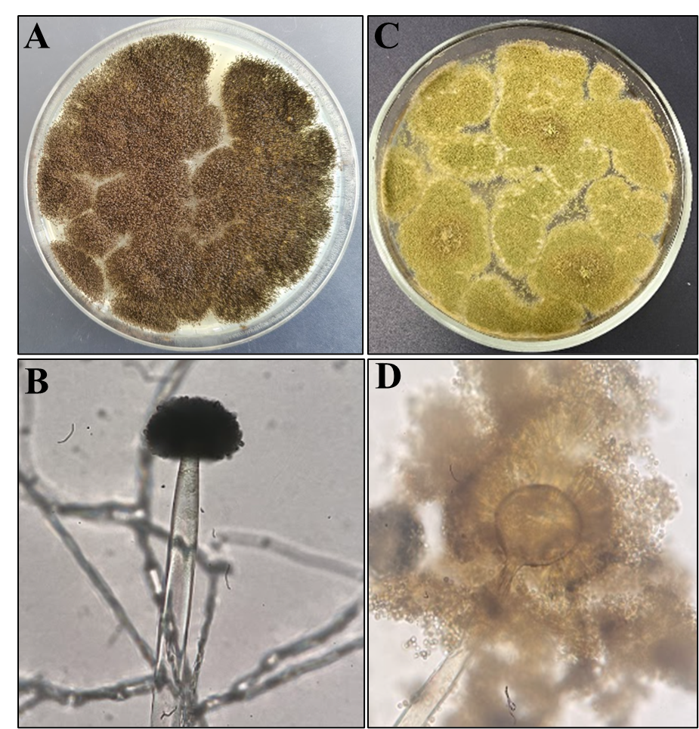

Figure 1. Cultural morphological characteristics of Aspergillus niger 1A and 1B; Aspergillus fumigatus 1С and 1D

Aspergillus niger colonies (Figure 1A and 1B) on PDA are characterized by rapid growth and intense sporulation. Initially, the mycelium is whitish, but as conidia form, the colony surface becomes dark brown or black. The colonies are dense, velvety-powdery, with a distinct radial structure and jagged edges. The colony diameter rapidly increases and can occupy a significant portion of the Petri dish. The colony reverse is usually light, yellowish-beige, or almost colorless.
Microscopic examination reveals a well-developed, septate, hyaline mycelium. The conidiophores are long, smooth, and colorless, ending in a spherical vesicle. The vesicle is completely covered with metulae and phialides, forming a radial structure. The phialides produce long chains of darkly pigmented conidia, giving the conidial head its characteristic black color. The conidia are spherical, rough-surfaced, and collected in dense radial heads.
Aspergillus fumigatus (Figure 1C and 1D) colonies on PDA medium are characterized by rapid growth and a velvety surface. Young colonies are initially whitish, later acquiring a characteristic gray-green or olive-green color as conidia form. The colony surface is dense, sometimes slightly folded, with jagged or slightly serrated edges. Colonies may form isolated areas of intense sporulation. The colony reverse is usually pale yellow or cream.
Microscopic examination reveals thin, septate mycelium and smooth conidiophores extending from the substrate mycelium. A club-shaped or slightly rounded vesicle form at the apex of the conidiophores. The phialides are arranged in a single row (uniserial) and cover only the upper portion of the vesicle. The conidial chains form a compact columnar head. The conidia are small, round, smooth or slightly rough, form long chains, and give the colonies their characteristic green color.
The phylogenetic tree included the ITS sequences obtained in this study together with reference sequences of Aspergillus species retrieved from the GenBank database.

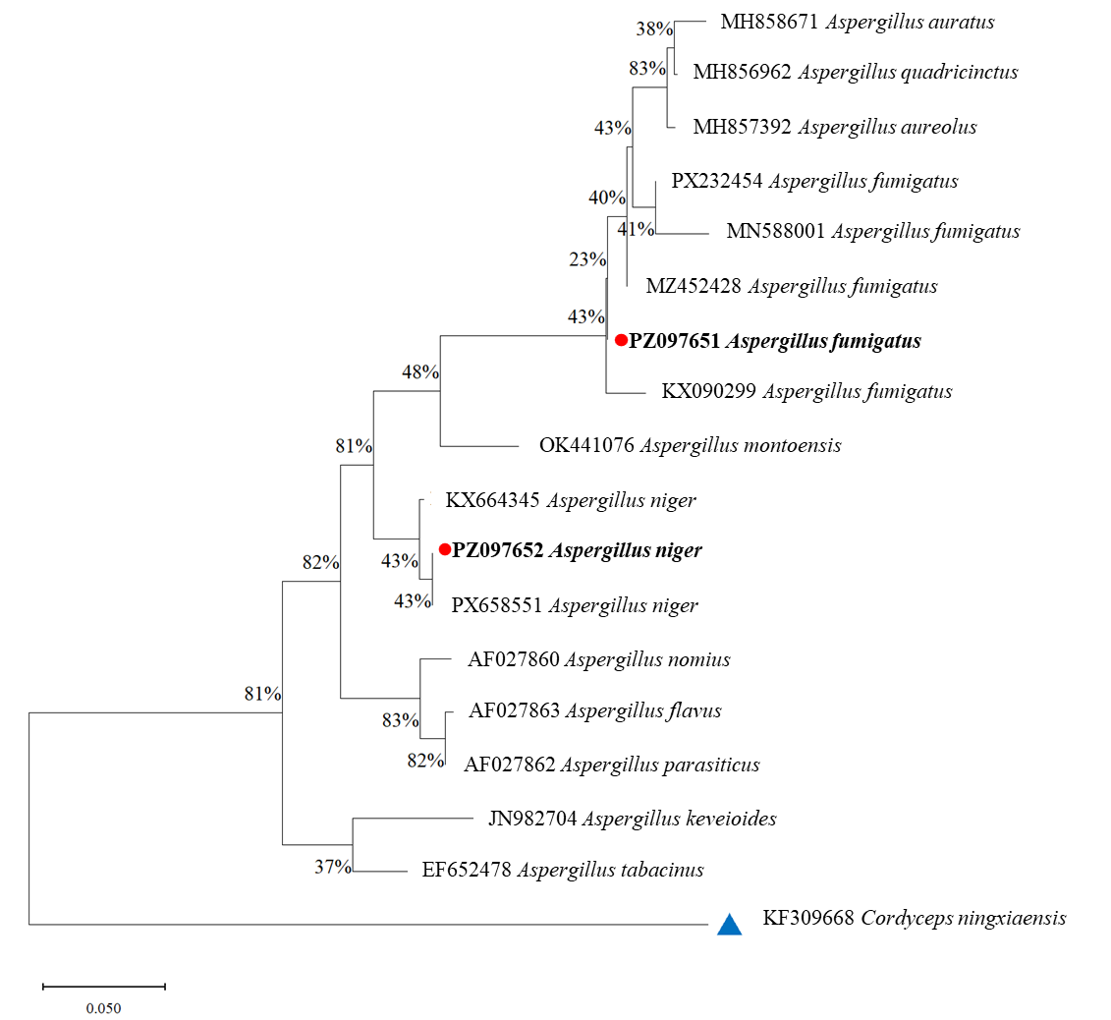

Figure 2. Maximum likelihood phylogenetic analysis of Aspergillus species based on the ITS gene among the studied isolates and reference sequences

In the phylogenetic tree, isolates obtained in the present study are indicated by red circles and bold text. One isolate (PZ097651) clustered with reference sequences of A. fumigatus (PX232454, MN588001, MZ452428, and KX090299), forming a clade corresponding to this species. Another isolate (PZ097652) grouped with reference sequences of A. niger (KX664345 and PX658551), confirming its placement within the A. niger lineage.
Bootstrap values indicated moderate to strong support for several nodes within the tree. To root the phylogenetic tree, Cordyceps ningxiaensis (KF309668) was used as an outgroup and is indicated by a blue triangle in the figure. The resulting topology clearly separated the analyzed isolates into distinct clades corresponding to recognized Aspergillus species.

Discussion

The phylogenetic analysis based on the ITS1 region confirmed that the fungal isolates obtained from chickpea seeds belong to the species Aspergillus fumigatus and Aspergillus niger. Both species are widely distributed saprophytic fungi commonly associated with stored agricultural products and are frequently reported as storage contaminants of grains and legumes [24, 25].
Species of the genus Aspergillus are well known for their ability to colonize seeds during post-harvest storage, particularly under conditions of elevated humidity and temperature [26]. Consequently, the isolation of A. niger and A. fumigatus from chickpea seeds indicates post-harvest fungal proliferation rather than active field infection. Similar findings have been reported in previous studies investigating fungal contamination of stored legumes and cereal grains [27, 28].
The detection of these species in chickpea seeds is also important from a food safety perspective. Several Aspergillus species are known to produce allergenic spores and secondary metabolites that may affect human health [29]. Consumption or inhalation of fungal spores may trigger allergic reactions or respiratory symptoms in susceptible individuals [30]. Beyond direct health implications, the contamination of chickpea batches by potential mycotoxin-producing Aspergillus strains represents a significant economic barrier.
As chickpea cultivation expands in Central Asia to meet growing global demand for plant-based proteins, adherence to strict international phytosanitary frameworks – such as the stringent mycotoxin limits enforced by the European Union – becomes paramount. Consequently, the identification of these specific storage pathogens is not merely a localized quality control issue, but a fundamental step in ensuring the export viability of regional agricultural commodities. Therefore, rigorous molecular monitoring of Aspergillus species in stored legumes is essential for maintaining food safety and mitigating health risks. Moving forward, addressing this contamination requires a shift toward integrated, agroecological storage management. Rather than relying on chemical fungicidal treatments, which may compromise organic certification and consumer safety, strategies should prioritize holistic environmental control. Implementing advanced moisture monitoring, optimizing natural aeration systems to disrupt condensation cycles, and exploring the application of bio-based fungal inhibitors or antagonistic microbial agents offer promising, sustainable pathways to enhance the resilience and safety of stored chickpea crops.

Author Contributions
K.D., R.U., V.K., A.S. - Conception and design; K.D., R.U., A.S. - Collection and assembly of data; K.D., R.U., A.S. - Data analysis and interpretation; K.D., R.U. - Manuscript writing; K.D., V.K. - Final approval of manuscript.

Funding
This work was financially supported by the Ministry of Science and Higher Education of the Republic of Kazakhstan (Grant No AP22787291).

Conflicts of Interest
All authors have no conflict of interest to declare.

Compliance with ethical standards
The authors are accountable for all aspects of the work in ensuring that questions related to the accuracy or integrity of any part of the work are appropriately investigated and resolved.

References:

- Sharma KK, Bhatnagar-Mathur P, Jayanand B. Chickpea (Cicer arietinum L.). Methods Mol Biol, 2006, 343:313-323. https://doi.org/10.1385/1-59745-130-4:313
- Thakur R, Sharma S, Devi R et al. Exploring the molecular basis of resistance to Botrytis cinerea in chickpea genotypes through biochemical and morphological markers. PeerJ. 2023, 11, e15560. https://doi.org/10.7717/peerj.15560
- Thakur R, Devi R, Lal MK et al. Morphological, ultrastructural and molecular variations in susceptible and resistant genotypes of chickpea infected with Botrytis grey mould. PeerJ, 2023, 11, e15134. https://doi.org/10.7717/peerj.15134
- Zhang J, Wang J, Zhu C et al. Chickpea: Its Origin, Distribution, Nutrition, Benefits, Breeding, and Symbiotic Relationship with Mesorhizobium Species. Plants, 2024,13(3):429. doi:10.3390/plants13030429
- Merga B, & Haji J. Economic importance of chickpea: Production, value, and world trade. Agriculture, 2019, 5(1). https://doi.org/10.1080/23311932.2019.1615718
- Quaglia M, Tini F, Bajrami E et al. Occurrence of Aspergillus and Penicillium Species, Accumulation of Fungal Secondary Metabolites, and qPCR Detection of Potential Aflatoxigenic Aspergillus Species in Chickpea (Cicer arietinum L.) Seeds from Different Farming Systems. Foods, 2025, 14(15), 2610. https://doi.org/10.3390/foods14152610
- Sharma AK, Kumar A & Rijal R. Phylogenetic studies and distinction of aflatoxin-producing Aspergillus species in section Flavi, Ochraceorosei and Nidulantes: A review. Gene, 2025, 937, 149151. https://doi.org/10.1016/j.gene.2024.149151
- Ramirez ML, Candoya E, Nichea MJ et al. Impact of toxigenic fungi and mycotoxins in chickpea: A review. Curr Opin Food Sci, 2018, 23:32–37. https://doi.org/10.1016/j.cofs.2018.05.003
- Shamsi S & Khatun A. Prevalence of fungi in different varieties of chickpea (Cicer arietinum L.) seeds in storage. J Bangladesh Acad Sci, 2016, 40:37–44. https://doi.org/10.3329/jbas.v40i1.28323
- Cota-Barreras CI, García-Estrada RS, León-Félix J et al. Phylogeny, distribution, and pathogenicity of fusarioid fungi associated with chickpea wilt in Sinaloa and Sonora, Mexico. Trop Plant Pathol, 2024, 49, 622–632. https://doi.org/10.1007/s40858-024-00663-3
- Alemayehu S, Abera FA, Aymut KM et al. Fungal infection and mycotoxins contamination on farm-stored chickpea in major producing districts of Ethiopia. J Biomed Res Environ Sci, 2023, 4:413–425. https://doi.org/10.37871/jbres1690
- Romero Donato CJ, Nichea MJ, Cendoya E et al. Interacting abiotic factors affect growth and mycotoxin production profiles of Alternaria section Alternaria strains on chickpea-based media. Pathogens, 2023, 12:565. https://doi.org/10.3390/pathogens12040565
- Pallavi S, Achyut B, Soni M et al. Morphological and Molecular Characterization of Aflatoxin Producing Strains of Aspergillus spp. in Groundnut from India. Cytol Genet, 2025, 59, 397–407. https://doi.org/10.3103/S0095452725040097
- Acuña-Gutiérrez C, Jiménez VM, Müller J. Occurrence of mycotoxins in pulses. Compr Rev Food Sci Food Saf, 2022, 21:4002–4017. https://doi.org/10.1111/1541-4337.13008
- Pisuttu C, Risoli S, Moncini L et al. Sustainable strategies to counteract mycotoxins contamination and cowpea weevil in chickpea seeds during post-harvest. Toxins, 2023, 15:61. https://doi.org/10.3390/toxins15010061
- Vitalini S, Iriti M & Vallone L. Mycotoxins in European Union Regulations (2023-2025). Italian Journal of Food Safety, 2025, 15(1):14096. https://doi.org/10.4081/ijfs.2025.14096
- Annunziata L, Campana G, De Massis MR et al. Ochratoxin A in Foods and Beverages: Dietary Exposure and Risk Assessment. Expo Health, 2025, 17, 481–494. https://doi.org/10.1007/s12403-024-00672-2
- Wang J, Sufar EK, Bernhoft A et al. Mycotoxin contamination in organic and conventional cereal grain and products: A systematic literature review and meta-analysis. Compr Rev Food Sci Food Saf, 2024, 23:e13363. https://doi.org/10.1111/1541-4337.13363
- Quaglia M, Beccari G, Vella GF et al. Marketed quinoa (Chenopodium quinoa Willd.) seeds: A mycotoxin-free matrix contaminated by mycotoxigenic fungi. Pathogens, 2023, 12:418. https://doi.org/10.3390/pathogens12030418
- Perrone G, Mulè G, Susca A et al. Ochratoxin A production and amplified fragment length polymorphism analysis of Aspergillus carbonarius, Aspergillus tubingensis, and Aspergillus niger strains isolated from grapes in Italy. Appl. Environ. Microbiol. 2006, 72:680–685. https://doi.org/10.1128/AEM.72.1.680-685.2006
- Rojas A, Bass LG, Campos-Camacho J et al. Integrative taxonomy in helminth analysis: protocols and limitations in the twenty-first century. Parasites Vectors, 2025, 18, 87. https://doi.org/10.1186/s13071-025-06682-6
- Zarrin M, Ganj F & Faramarzi S. Analysis of the rDNA internal transcribed spacer region of the Fusarium species by polymerase chain reaction-restriction fragment length polymorphism. Biomedical reports, 20164(4), 471–474. https://doi.org/10.3892/br.2016.615
- Tamura K, Stecher G & Kumar S. MEGA 11: Molecular Evolutionary Genetics Analysis Version 11. Mol Biol Evol, 2021, 38(7):3022-7. https://doi.org/10.1093/molbev/msab120
- Magan N, & Aldred D. Post-harvest control strategies: minimizing mycotoxins in the food chain. Intern J Food Microbiol, 2007, 119(1-2), 131–139. https://doi.org/10.1016/j.ijfoodmicro.2007.07.034
- Samson RA, Visagie CM, Houbraken J et al. Phylogeny, identification and nomenclature of the genus Aspergillus. Studies in mycology, 2014, 78, 141–173. https://doi.org/10.1016/j.simyco.2014.07.004
- Martín I, Gálvez L, Guasch L et al. Fungal Pathogens and Seed Storage in the Dry State. Plants, 2022, 11(22):3167. https://doi.org/10.3390/plants11223167
- Nada S, Nikola T, Bozidar U et al. Prevention and practical strategies to control mycotoxins in the wheat and maize chain. Food Control, 2022, 136, 108855. https://doi.org/10.1016/j.foodcont.2022.108855
- Syraji Y, Jeyaramraja PR, Mada T et al. Comprehensive review of aflatoxin contamination, its occurrence, effects, management, and future perspectives. Discov Food, 2025, 5, 377. https://doi.org/10.1007/s44187-025-00680-4
- Magan N, Aldred D, Mylona K et al. Limiting mycotoxins in stored wheat. Food Addit Cont, 2010, 1;27(5):644-50. https://doi.org/10.1080/19440040903514523
- Chulze SN. Strategies to reduce mycotoxin levels in maize during storage: a review. Food Addit Cont, 2010, 27(5), 651–657. https://doi.org/10.1080/19440040903573032

Қазақстанның Ақмола облысындағы ноқат тұқымдарындағы Aspergillus сақтау саңырауқұлақтарының молекулалық идентификациясы және әртүрлілігі

Р.С. Уахит¹, А.М. Смагулова¹, А.С. Абаш², В.С. Киян¹, К.А. Дюсембаев^{1,3*}

¹Биоәртүрлілік және генетикалық ресурстар зертханасы, Ұлттық биотехнология орталығы, Астана, Қазақстан
²Жаратылыстану ғылымдарының жоғары мектебі, Астана халықаралық университеті, Астана, Қазақстан
³Биотехнология және микробиология кафедрасы, Л.Н. Гумилев атындағы Еуразия ұлттық университеті, Астана, Қазақстан

E-mail: erken.uakhitrabiga@gmail.com¹, smagulova0114@gmail.com², altın_jan82mail.ru³, vskiyan@gmail.com⁴, dyussembayev@biocenter.kz⁵

Аңдатпа. Ноқат (Cicer arietinum L.) – егін жинаудан кейінгі сапасы жиі оппортунистік сақтау саңырауқұлақтарымен төмендейтін, микотоксиндермен ластануына байланысты экономикалық шығындарға және денсаулыққа әлеуетті қауіп төндіретін маңызды бұршақ дақылы. Оның ауылшаруашылық маңызына қарамастан, Қазақстанда ноқат тұқымдарын зақымдайтын сақтау саңырауқұлақтары туралы ақпарат шектеулі күйде қалып отыр. Бұл зерттеудің мақсаты Ақмола облысында өсірілген ноқат тұқымдарын ластайтын Aspergillus түрлерін бөліп алу және анықтау болды. Жергілікті ауылшаруашылық өндірісінен алынған 200-ден астам тұқым үлгілері бағаланды. Бастапқы микробиологиялық талдау мен микроскопиялық зерттеуден кейін рибосомалық ДНҚ-ның ішкі транскрипцияланатын спейсері (ITS) аймағын амплификациялау және секвенирлеу арқылы нақты молекулалық идентификация жасалды. Алынған тізбектердің филогенетикалық талдауы екі түрлі түрдің: Aspergillus niger және Aspergillus fumigatus бар екенін растады. Осы барлық жерде таралған сапрофиттердің бөлініп алынуы жергілікті климаттық факторлар мен қойма микроклиматы әсерінен ушығатын, егін жинаудан кейінгі саңырауқұлақтардың айтарлықтай көбеюін көрсетеді. Бұл нәтижелер аймақтық егін жинаудан кейінгі инфрақұрылымдағы маңызды осалдықты көрсетеді және қатаң фитосанитариялық мониторинг қажеттілігін баса айтады. Жақсартылған, тұрақты сақтауды басқару стратегияларын енгізу саңырауқұлақтармен ластануды азайту және жергілікті ауылшаруашылық өнімдерінің қауіпсіздігін қамтамасыз ету үшін өте маңызды.
Түйін сөздер: Cicer arietinum, сақтау саңырауқұлақтары, Aspergillus niger, Aspergillus fumigatus, ITS рДНҚ, фитосанитариялық мониторинг, егін жинаудан кейінгі сапа

Молекулярная идентификация и разнообразие грибов хранения Aspergillus в семенах нута в Акмолинской области Казахстана

Р.С. Уахит¹, А.М. Смагулова¹, А.С. Абаш², В.С. Киян¹, К.А. Дюсембаев^{1,3*}

¹Лаборатория биоразнообразия и генетических ресурсов, Национальный центр биотехнологии, Астана, Казахстан;
²Высшая школа естественных наук, Международный университет Астана, Астана, Казахстан;
³Кафедра биотехнологии и микробиологии, Евразийский национальный университет имени Л.Н. Гумилева, Астана, Казахстан

E-mail: erken.uakhitrabiga@gmail.com¹, smagulova0114@gmail.com², altın_jan82mail.ru³, vskiyan@gmail.com⁴, dyussembayev@biocenter.kz⁵

Аннотация. Нут (Cicer arietinum L.) – важная зернобобовая культура, послеуборочное качество которой часто снижается из-за оппортунистических грибов хранения, что приводит к экономическим потерям и потенциальным рискам для здоровья в связи с контаминацией микотоксинами. Несмотря на его сельскохозяйственное значение, информация о грибах хранения, поражающих семена нута в Казахстане, остается ограниченной. Целью данного исследования было выделение и идентификация видов Aspergillus, контаминирующих семена нута, выращенного в Акмолинской области. Было оценено более 200 образцов семян, полученных из местного сельскохозяйственного производства. После первичного микробиологического анализа и микроскопического исследования была проведена точная молекулярная идентификация путем амплификации и секвенирования региона внутреннего транскрибируемого спейсера (ITS) рибосомной ДНК. Филогенетический анализ полученных последовательностей подтвердил наличие двух различных видов: Aspergillus niger и Aspergillus fumigatus. Выделение этих повсеместно распространенных сапрофитов указывает на значительное размножение послеуборочных грибов, усугубляемое местными климатическими факторами и микроклиматом хранилищ. Эти результаты выявляют значительную уязвимость в региональной послеуборочной инфраструктуре и подчеркивают необходимость строгого фитосанитарного мониторинга. Внедрение улучшенных, устойчивых стратегий управления хранением имеет решающее значение для снижения грибковой контаминации и обеспечения безопасности местной сельскохозяйственной продукции.
Ключевые слова: Cicer arietinum, грибы хранения, Aspergillus niger, Aspergillus fumigatus, ITS рДНК, фитосанитарный мониторинг, послеуборочное качество

Авторлар туралы мәлімет:
Уахит Рабиға Сейтбатталқызы – PhD, Ұлттық биотехнология орталығы Биоәртүрлілік және генетикалық ресурстар зертханасының аға ғылыми қызметкері, 010000, Астана, Қазақстан.
Смагулова Айнура Муратовна – биология ғылымдарының кандидаты, Ұлттық биотехнология орталығы Биоәртүрлілік және генетикалық ресурстар зертханасының аға ғылыми қызметкері, 010000, Астана, Қазақстан.
Абаш Алтынгүл Сембайқызы – Астана халықаралық университеті Жаратылыстану ғылымдары жоғары мектебінің докторанты, 010000, Астана, Қазақстан.
Киян Владимир Сергеевич – PhD, профессор, Ұлттық биотехнология орталығы Биоәртүрлілік және генетикалық ресурстар зертханасының меңгерушісі, 010000, Астана, Қазақстан.
Дюсембаев Казбек Амзеұлы – хат-хабар авторы, PhD, Ұлттық биотехнология орталығы Биоәртүрлілік және генетикалық ресурстар зертханасының ғылыми қызметкері, 010000, Астана, Қазақстан; Л.Н. Гумилев атындағы Еуразия ұлттық университеті Биотехнология және микробиология кафедрасының аға оқытушысы, 010000, Астана, Қазақстан.

Сведения об авторах:
Уахит Рабиға Сейтбатталқызы – PhD, старший научный сотрудник Лаборатории биоразнообразия и генетических ресурсов Национального центра биотехнологии, 010000, Астана, Казахстан.
Смагулова Айнура Муратовна – кандидат биологических наук, старший научный сотрудник Лаборатории биоразнообразия и генетических ресурсов Национального центра биотехнологии, 010000, Астана, Казахстан.
Абаш Алтынгүл Сембайқызы – докторант Высшей школы естественных наук Международного университета Астана, 010000, Астана, Казахстан.
Киян Владимир Сергеевич – PhD, профессор, заведующий Лабораторией биоразнообразия и генетических ресурсов Национального центра биотехнологии, 010000, Астана, Казахстан.
Дюсембаев Казбек Амзеұлы – автор для корреспонденции, PhD, научный сотрудник Лаборатории биоразнообразия и генетических ресурсов Национального центра биотехнологии, 010000, Астана, Казахстан; старший преподаватель кафедры биотехнологии и микробиологии Евразийского национального университета имени Л.Н. Гумилева, 010000, Астана, Казахстан.

Authors' information:
Rabiga Uakhit – PhD, senior research scientist, Laboratory of Biodiversity and Genetic Resources, National Center for Biotechnology, 010000, Astana, Kazakhstan.
Ainura Smagulova – Candidate of biological sciences, senior research scientist, Laboratory of biodiversity and genetic resources, National Center for Biotechnology, 010000, Astana, Kazakhstan.
Altyngul Abash – PhD student, Higher school of natural sciences, Astana international university, 010000, Astana, Kazakhstan.
Vladimir Kiyan – PhD, professor, head of the Laboratory of Biodiversity and genetic resources, National Center for Biotechnology, 010000, Astana, Kazakhstan.
Kazbek Dyussembayev – corresponding author, research scientist, Laboratory of biodiversity and genetic resources, National Center for Biotechnology, 010000, Astana, Kazakhstan; senior lecturer, Department of biotechnology and microbiology, L.N. Gumilyov Eurasian National University, 010000, Astana, Kazakhstan.

